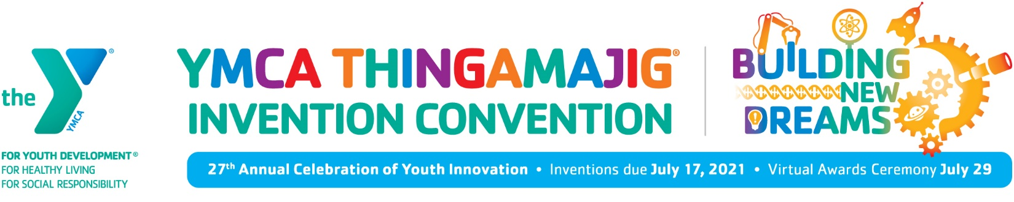

FOR IMMEDIATE RELEASE
Contact: Linda Blake
Assn Director of Marketing and Community Relations
Linda.Blake@ymcadc.org; 202-536-8394

REGISTRATION FOR THE Y’S THINGAMAJIG INVENTION CONVENTION
IS OPEN AND READY FOR YOUNG INVENTORS TO START BUILDING NEW DREAMS

Children can create inventions, learn more about STEM, win prizes
and celebrate their achievements all virtually

WASHINGTON, D.C. – July 8, 2021 –- In 2021, the YMCA of Metropolitan Washington will celebrate 27 years of hosting the THINGAMAJIG® Invention Convention. As our nation gradually opens back up from the pandemic, THINGAMAJIG will delay being held at its annual location at the Prince George's County Show Place Arena in Upper Marlboro, Maryland. THINGAMAJIG will be re-imagined again this year as a virtual program where children can still participate in amazing STEM learning.

Recognized as the YMCA of Metropolitan Washington’s signature event, the THINGAMAJIG Invention Convention challenges youth to use their creativity, imagination, recyclables, engineering design process and a bit of trial and error to solve a challenge. They are encouraged to design, build, and present their original prototypes in the Invention Competition. Recognition and prizes will be awarded based on a set of judging criteria.

The THINGAMAJIG Invention Convention is designed to connect young people ages 5-14 to the importance and relevance of science and technology in all aspects of living. THINGAMAJIG also motivates them to use their imagination, creativity and strategic thinking to “think outside of the box” and explore STEM in a manner that is highly engaging.

Children have several weeks to plan, design and construct inventions using recyclable materials based on provided categories through the virtual host, dc-thingamajig.zfairs.com. Inventions can be submitted individually or as a team. Volunteers serve as judges in each invention category.

For details and to register, visit https://dc-thingamajig.zfairs.com
- Create your unique invention with recycled materials at home selected from one of the provided categories listed in dc-thingamajig.zfairs.com.
- Upload a video and logbook of your invention by July 17.
- Join us July 29 for an exciting THINGAMAJIG Day to have fun as well as celebrate all of the inventions and achievements.

# # #
About YMCA of Metropolitan Washington
The YMCA of Metropolitan Washington is a 501©3 non-profit charity organization that has been serving the communities and families of Washington, D.C., Maryland and Virginia in the areas of youth development, healthy living and social responsibility, for nearly 168 years. Through opportunities in wellness, aquatics, youth sports, summer camps, childcare and more, the Y engages more than 250,000 individuals and families. Visit www.ymcadc.org for more information.

